Susan Liu

933237062

CS475

4/23/2021

1. What Machine was used to run program

OS1

2. What do you think the actual volume is?

The actual volume is around 0.435761 units.

3.Show the performance you achieved in tables and two graphs showing

a. Performance as a function of NUMNODES with colored lines showing different NUMT values

b. Performance as a function of NUMT with colored lines showing different NUMNODES values

**FYI I’m calculating Numnodes2**

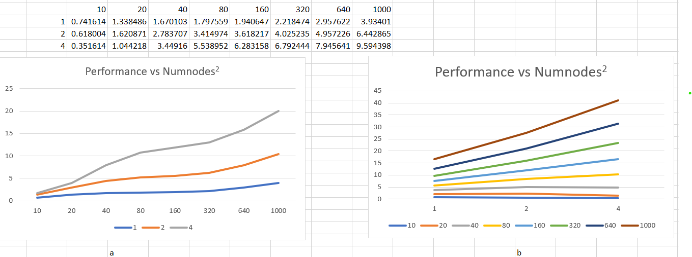

4. What patterns are you seeing in the speeds?

The performance of the threads is increasing as the Numnodes2 are increasing.

5. Why do you think it is behaving this way?

I think the reason the performance time is increasing is because that it is taking longer time for the program to calculate the volume of the tile, since the floor area is increasing with Numnodes2.

6. What is the Parallel Fraction for this application, using the Inverse Amdahl's equation?

Fp = 4/3*(1-(1/9.594398/3.934010)

= (4/3) *(1-(1/2.43883417)

= 0.442476016

7. Give that Parallel Fraction, what is the maximum speed-up you could ever get?

The maximum speed up is

= 1/(1-0.786624028)

= 4.6865633

**FYI I’m calculating Numnodes2**